MongoDB -Aggregation Exercises
Import the zips.json file into your MongoDB. Database name is "population" and collection name is "zipcodes".
mongoimport --db population --collection zipcodes --file zips.json
Atlanta Population
- use db.zipcodes.find() to filter results to only the results where city is ATLANTA and state is GA.
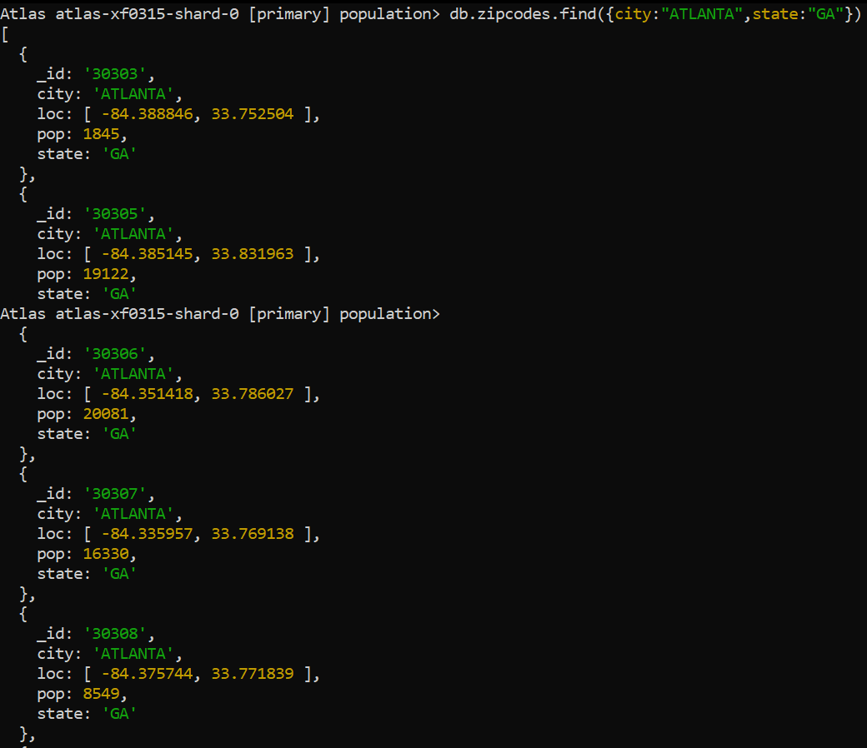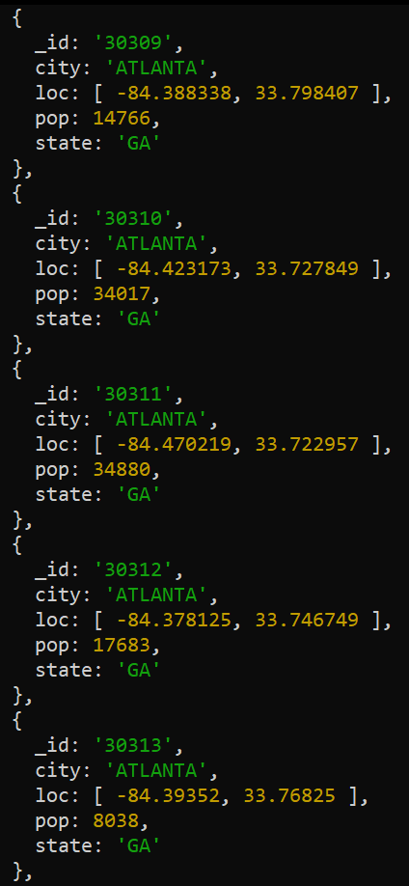
There are 31 documents with city name ‘ATLANTA’ and state name ‘GA’
- use db.zipcodes.aggregate with $match to do the same as above.
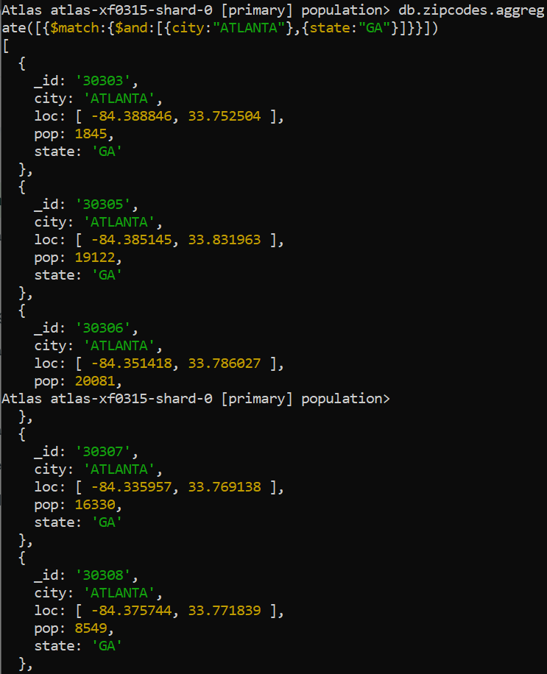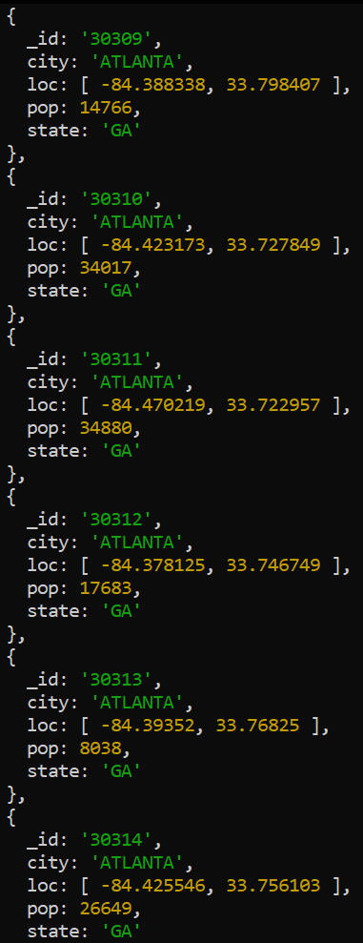
- use $group to count the number of zip codes in Atlanta.
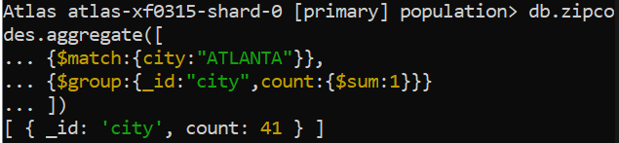
- use $group to find the total population in Atlanta.
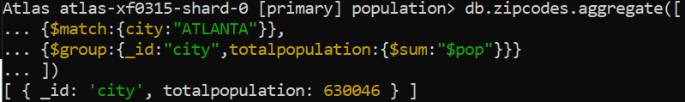
Populations By State
- use aggregate to calculate the total population for each state
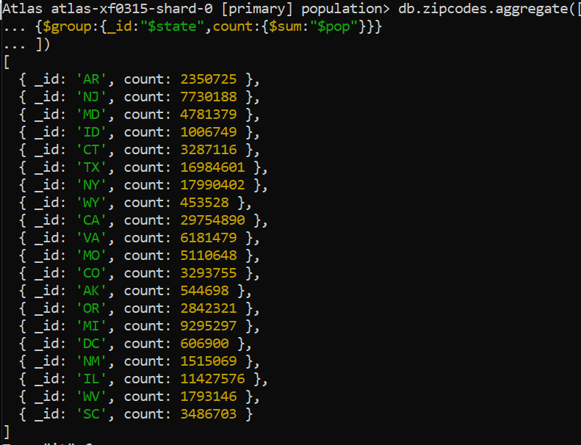
- sort the results by population, highest first
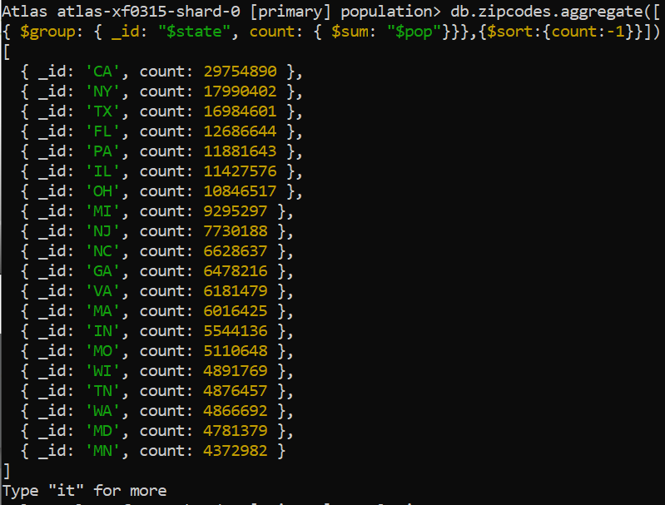

- limit the results to just the first 3 results. What are the top 3 states in population?
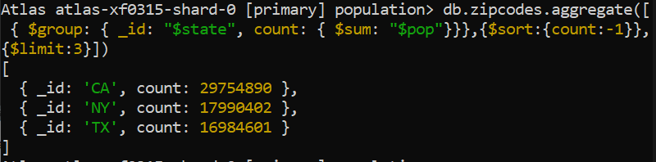
Populations by City
- use aggregate to calculate the total population for each city (you have to use city/state combination). You can use a combination for the _id of the $group: { city: '$city', state: '$state' }
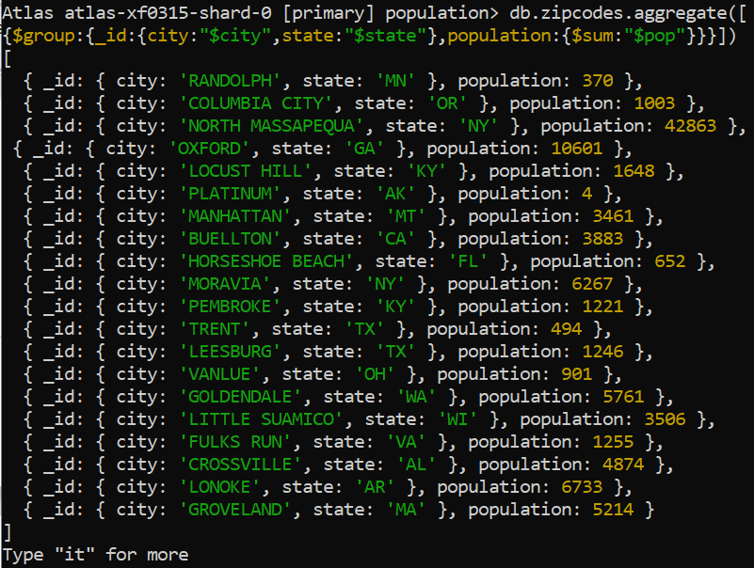

- sort the results by population, highest first
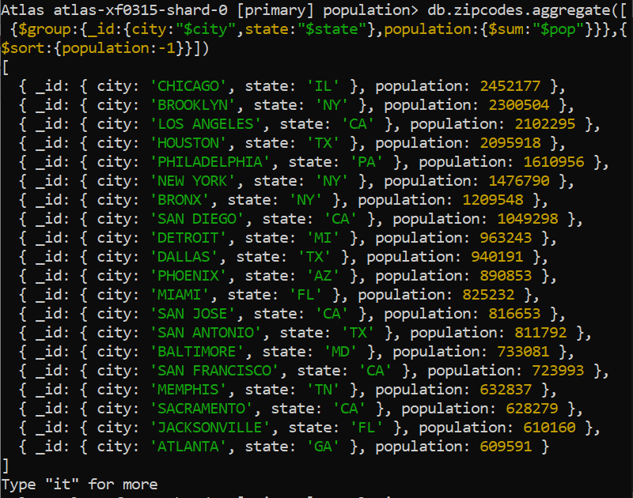
- A. Limit the results to just the first 3 results.
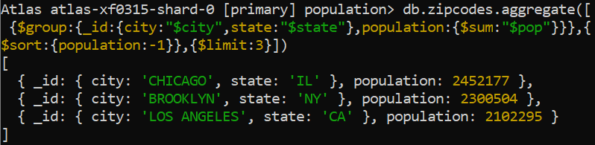
- What are the top 3 cities in population?
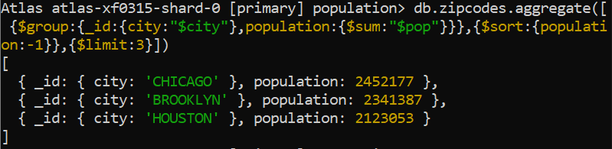

- What are the top 3 cities in population in Texas?
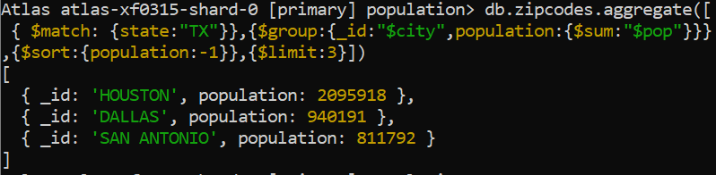
Bonus
- Write a query to get the average city population for each state.
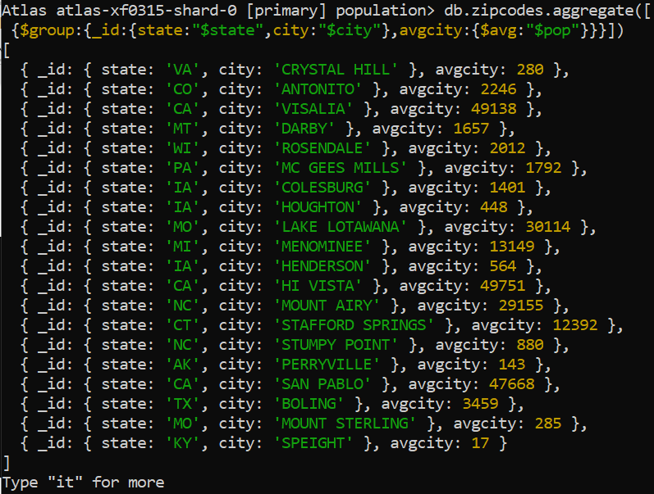
- What are the top 3 states in terms of average city population?
